**PROBLEM :** [**https://codeforces.com/contest/16/problem/E**](https://codeforces.com/contest/16/problem/E)

**APPROACH :**

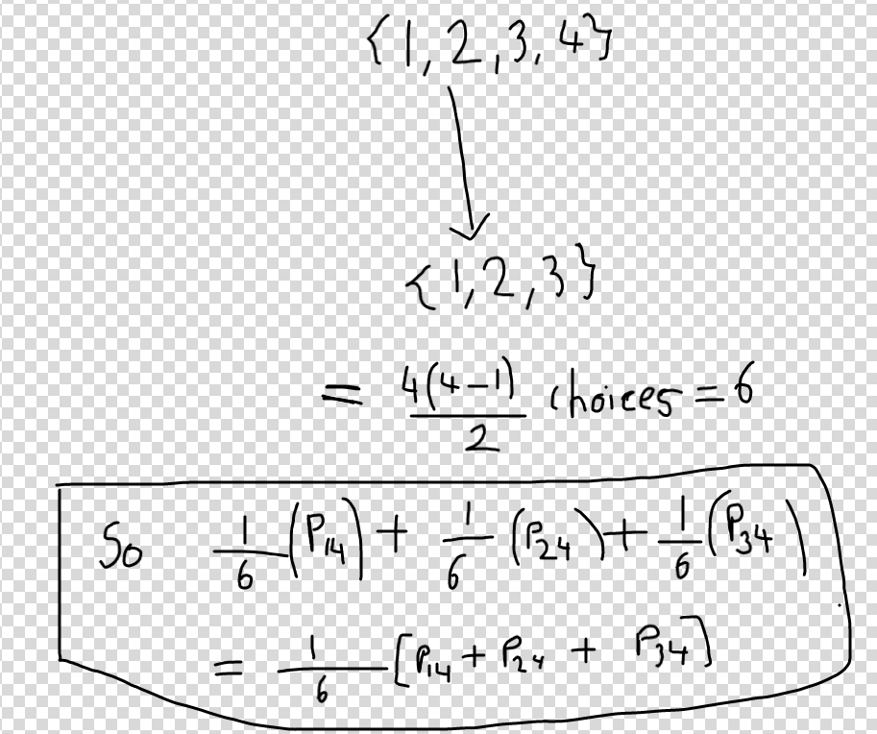

-> From state {1,2,3,4},lets think how we can reach state {1,2,3}, means fish 4 dies.

-> Now for ‘n’ alive fishes ,there are **nC2 =( n*(n-1))/2** ordered pairs , and any of these pairs can be equiprobably chosen,and the 2 fishes in the pair will fight and 1 will die.

-> So fish 4 will possibly die only if one of these pairs {1,4},{2,4},{3,4} will be selected.

-> So probab. That pair {1,4} is chosen is 1/nC2 and prob. that fish 1 wins is P14, so

(1/nC2)* P14, same with other pairs, the equation is solved in above fig.

-> So the below fig. Shows the whole transitions from **all 4 fish alive to only fish no 1 alive,** same way this could be extended for all fishes.

-> We can solve this 2 ways, whether to exploit tree from {1} to {1,2,3,4} or {1,2,3,4} to {1},lets see the 1st one, **which is bottom up.**

-> So for fish no 1, in the previous stage it could have come from {1,2},{1,3},{1,4}.

-> So we find recursively **prob to reach {1,2} * prob to reach {1}[already discussed above how to move to a set with 1 less element]**

And same way for {1,3},{1,4} and so on , and add all of them, and that will be the prob. To reach {1}

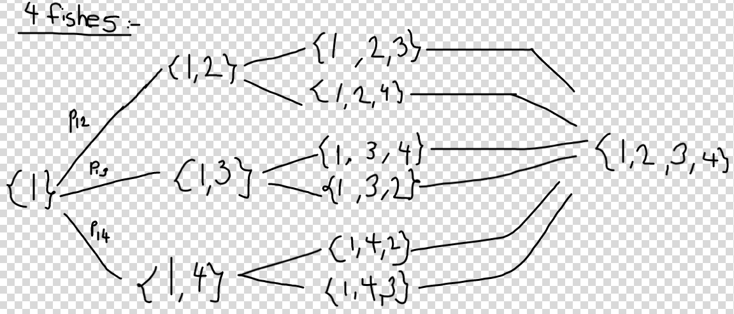

**-> Again so many OVERLAPPING SUBPROBLEMS like {1,2,4},{1,4,3} and so on...which can be saved using Bitmasking.**

**->As we visit 2^n unique states, time is O(2^n).**

**->** Using top down approach , we can just send {1,2,3} the probability to reach there from {1,2,3,4} , and then {1,2} the probability to reach there from {1,2,3} , and then finally done when reach {1}, and this is a top down approach(as we solve the problem when we reach the bottom)

-> If still can’t get the approach, then see 5 mins from the timestamped link below:

<https://youtu.be/d7kvyp6dfz8?t=653>

**CODE :** [**https://codeforces.com/contest/16/submission/122761740**](https://codeforces.com/contest/16/submission/122761740)